- Install scikit-learn if you haven't already, then load the iris dataset and fit a GradientBoostingClassifier to classify the flower species. Print the model's accuracy on the test set.
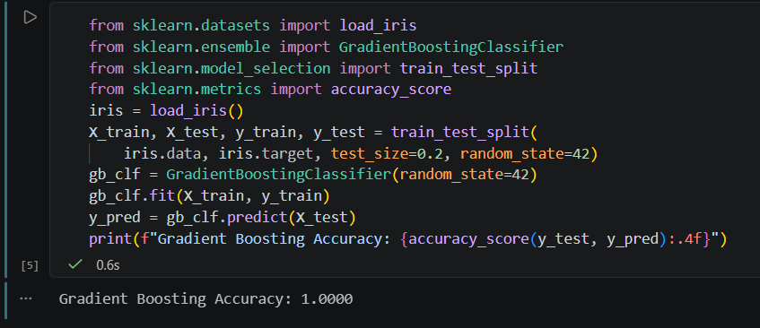

- Using the Flipkart product review dataset (or any small CSV with positive/negative labels), train an AdaBoostClassifier to predict if a review is positive or negative. Show the classification report (precision, recall, f1-score) for your model. You can use sklearn's AdaBoostClassifier and train_test_split.

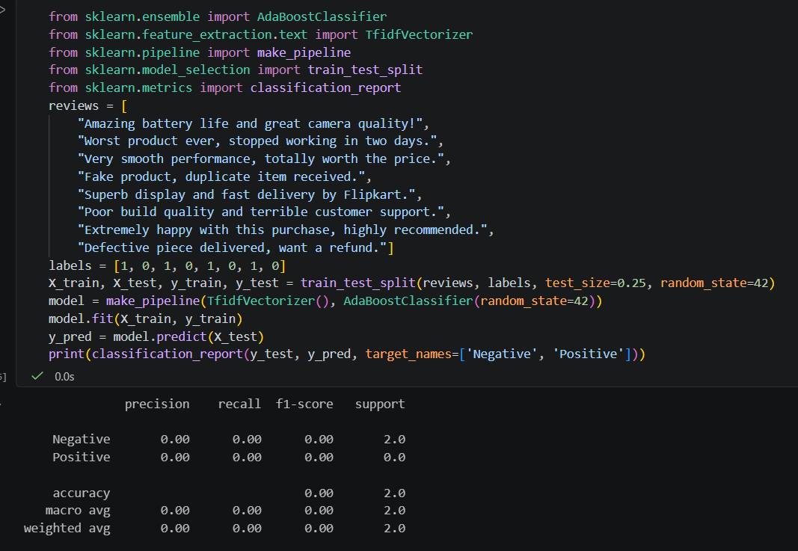
- Explain in your own words the difference between a weak learner and a strong learner, and give one real-world example of each from apps you use (like Instagram, Zomato, or Paytm).
Weak Learner vs. Strong Learner
- Weak Learner: A machine learning model that performs only slightly better than random guessing (e.g., a shallow decision tree with a maximum depth of 1, often called a decision stump). It has high bias and low predictive complexity.
- Strong Learner: A high-performing model that achieves high accuracy by capturing complex patterns and relationships in the data. Boosting algorithms systematically combine multiple weak learners to build this strong model.
- Real-World Examples:
  - Weak Learner: A simple feature filter on an app like Zomato that checks only whether a restaurant's rating is above 4.0 or not to predict if it will be crowded.
  - Strong Learner: Zomato's overarching recommendation engine that synthesizes historical order patterns, real-time traffic, delivery agent proximity, user food preferences, and time of day to accurately predict exact delivery times.

- Modify your GradientBoostingClassifier code to tune the n_estimators and learning_rate parameters. Try at least 3 different combinations and report which one gives the best accuracy. n_estimators controls the number of boosting stages, learning_rate shrinks the contribution of each tree.

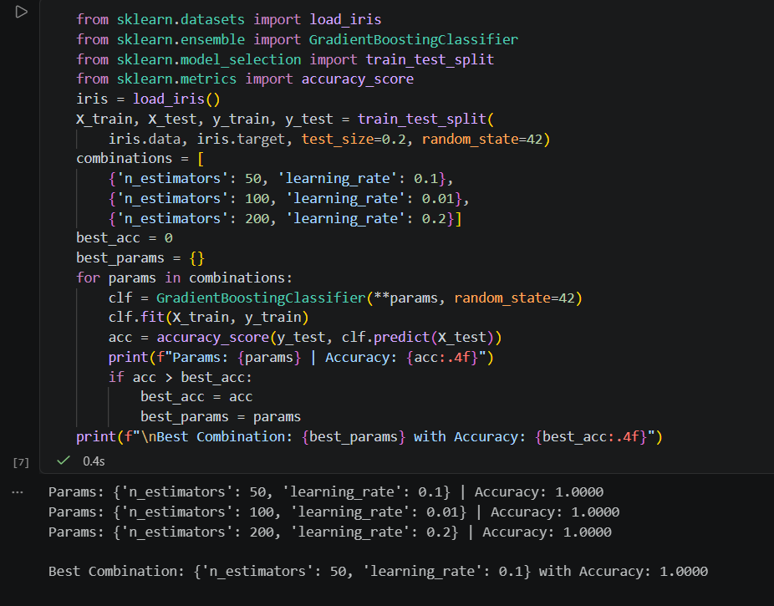

- Find a real-world use case of boosting in a popular Indian app (such as fraud detection in Paytm or spam filter in WhatsApp). Write 3-4 lines describing how boosting could improve the app's performance.

Boosting in a Popular Indian App (Paytm Fraud Detection)
- Use Case: Real-time transaction fraud detection on Paytm.
- How Boosting Improves Performance:
  - Gradient boosting algorithms (like XGBoost or LightGBM) sequentially train decision trees where each new tree specifically focuses on correcting the residual errors and misclassifications made by previous trees.
  - In digital payment ecosystems, fraudulent transactions represent rare, complex, and evolving patterns. Boosting handles tabular financial metadata (such as transaction velocity, device fingerprints, and geolocation shifts) with high precision.
  - By dynamically tuning weights on hard-to-detect fraud cases, boosting minimizes false declines for genuine users while instantly flagging high-risk transfers within milliseconds.

